**Task 1**

**1. Create the database named "TechShop";**

**CREATE DATABASE Techshop;**

2. Define the schema for the Customers, Products , Orders, OrderDetails and Inventory tables based on the provided schema.

**CREATE TABLE Customers(CustomerID integer , FirstName varchar(20), LastName varchar(20),Email varchar(25),Phone varchar(10) UNIQUE,Address varchar(50) ,CONSTRAINT Customers_customerID_pk PRIMARY KEY(CustomerID));**

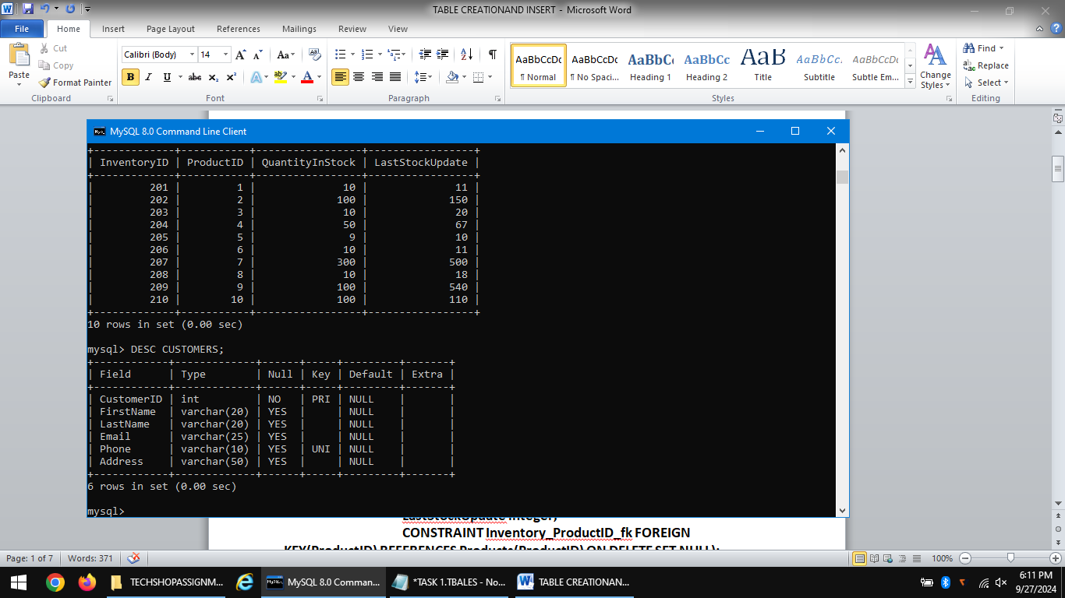

**CREATE TABLE Products(ProductID integer ,**

**ProductName varchar(20) , Description varchar(30),**

**price integer ,**

**CONSTRAINT Products_productID_pk PRIMARY KEY(ProductID)**

**);**

**CREATE TABLE Orders(OrderID integer Primary Key,CustomerID int REFERENCES Customers(CustomerID) ,Orderdate Date,TotalAmount int);** 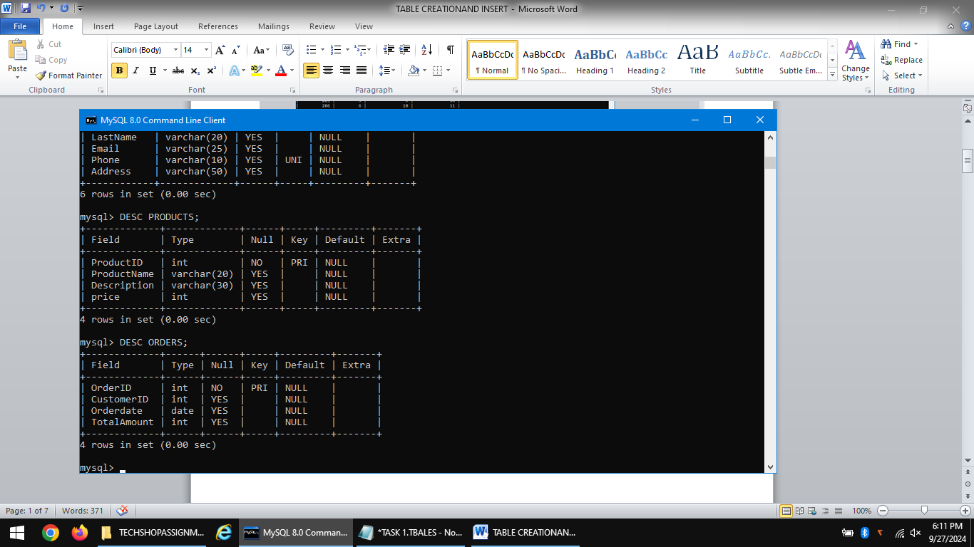

**CREATE TABLE OrderDetails(OrderDetailID integer ,**

**OrderID integer ,**

**ProductID integer,**

**Quantity integer,**

**FOREIGN KEY(OrderID) REFERENCES orders(OrderID) ON DELETE SET NULL , FOREIGN KEY(ProductID) REFERENCES Products(ProductID) ON DELETE SET NULL );**

**CREATE TABLE Inventory(InventoryID integer PRIMARY KEY,**

**ProductID integer,**

**QuantityInStock integer,**

**LastStockUpdate integer,**

**CONSTRAINT Inventory_ProductID_fk FOREIGN KEY(ProductID) REFERENCES Products(ProductID) ON DELETE SET NULL);**

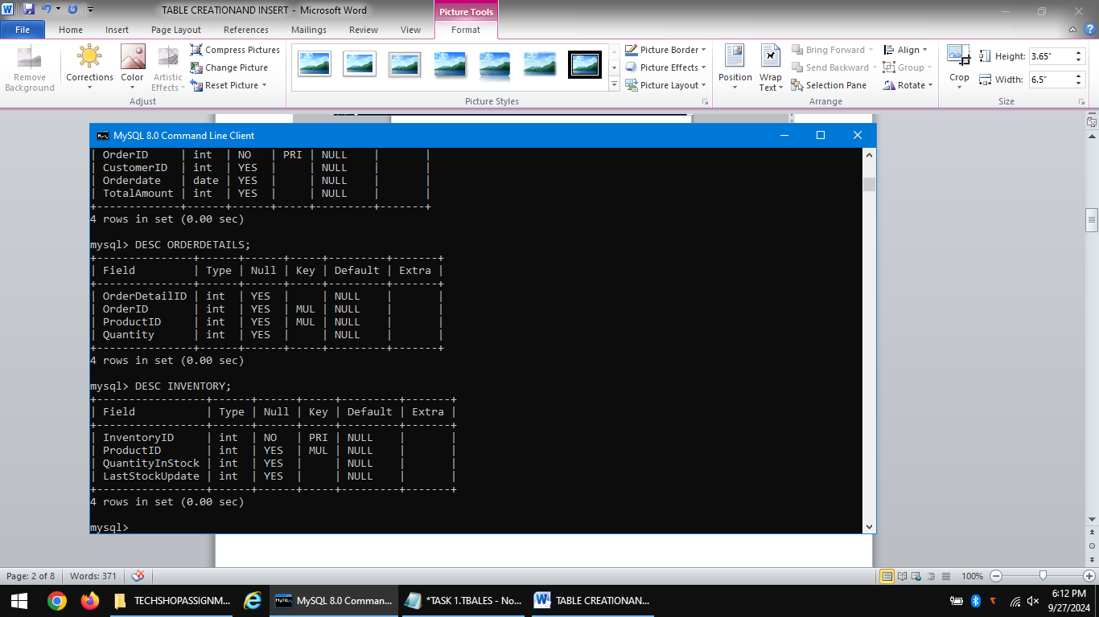

**INSERT------> CUSTOMERS**

**INSERT INTO Customers VALUES(101,'Raju','Bhai','mrajubhai@gmail.com','9867565456','No 4 ,Northstreet,Chennai');**

**INSERT INTO Customers VALUES(102,'Jagan',NULL,'jagan@gmail.com','9867567456','No 78/4 ,Northstreet,Chennai');**

**INSERT INTO Customers VALUES(103,'Siva','singh','sivasingh@gmail.com','9967565456','No 23 ,Weststreet,Chennai');**

**INSERT INTO Customers VALUES(104,'Lakshmi','Bhai','Lakshmi@gmail.com','6367565456','No 67 ,southstreet,Chennai');**

**INSERT INTO Customers VALUES(105,'Sarat',NULL,'sarat@gmail.com','9067565456','No 34/3 ,Bridgestreet,Chennai');**

**INSERT INTO Customers VALUES(106,'Sabari','Deva','sabari@gmail.com','8967565456','No 98/78 ,Weststreet,Madurai');**

**INSERT INTO Customers VALUES(107,'Devi',NULL,'devi@gmail.com','9064565456','No 78 ,Mainstreet,Delhi');**

**INSERT INTO Customers VALUES(108,'Muthu','Raji','muthuraj@gmail.com','6567565456','No 234 ,Templestreet,Jaipur');**

**INSERT INTO Customers VALUES(109,'Prema',NULL,'prema@gmail.com','7867565456','No 90 ,Holytreet,UP');**

**INSERT INTO Customers VALUES(110,'Bharathi','Kumar','kumar@gmail.com','667565456','No 45/7 ,Populartreet,Kerala');**

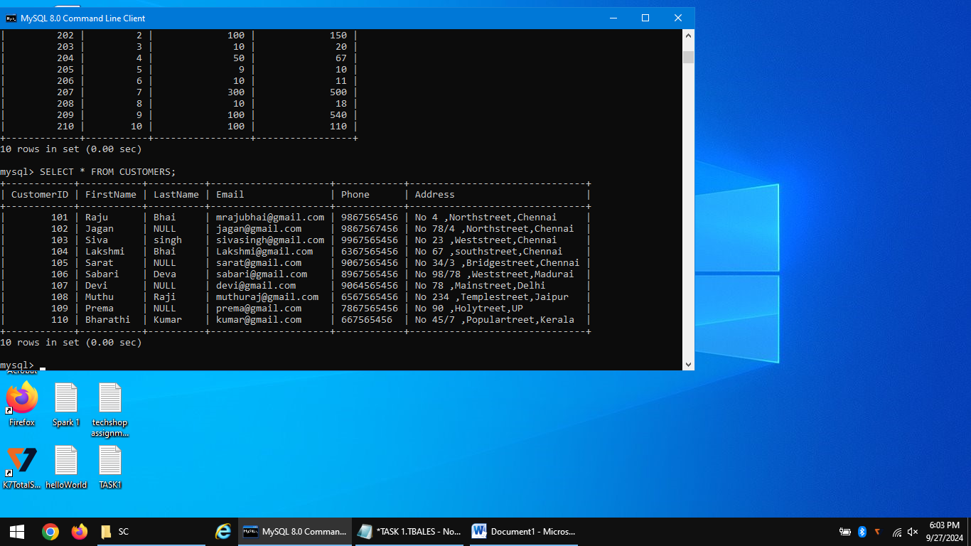

**INSERT------>PRODUCTS**

**INSERT INTO Products VALUES(1,'Light','40V Power',250);**

**INSERT INTO Products VALUES(2,'Fan','High power',5250);**

**INSERT INTO Products VALUES(3,'iPhone','14 pro',122250);**

**INSERT INTO Products VALUES(4,'Light',NULL,250);**

**INSERT INTO Products VALUES(5,'Laptop','HP',52250);**

**INSERT INTO Products VALUES(6,'Power bank','400V Power',250);**

**INSERT INTO Products VALUES(7,'Android phone','Vivoy30',3000);**

**INSERT INTO Products VALUES(8,'Fan','50V Power',1100);**

**INSERT INTO Products VALUES(9,'Bulb','20V Power',200);**

**INSERT INTO Products VALUES(10,'Modem','30B bandwidth',1800);**

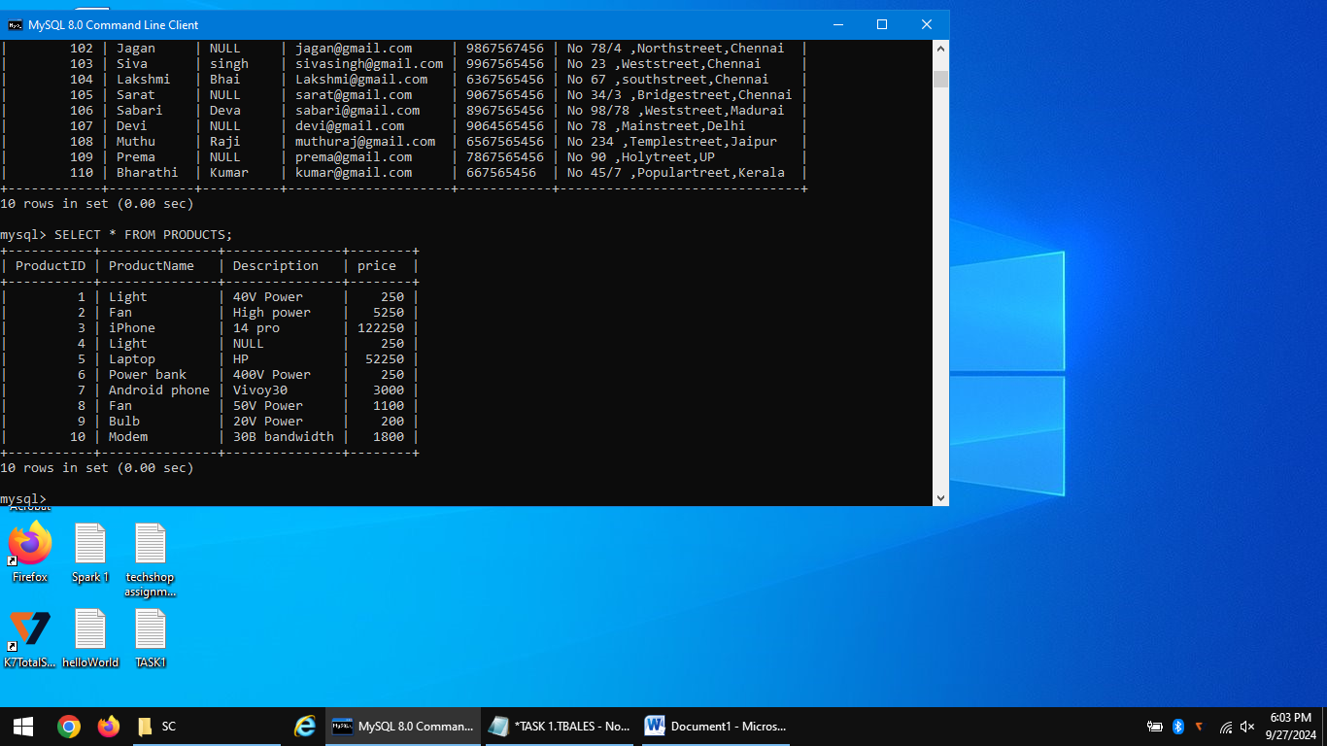

**INSERT---->ORDERS**

**INSERT INTO Orders VALUES(11,101,'2024-09-25',3000);**

**INSERT INTO Orders VALUES(12,101,'2024-03-30',200);**

**INSERT INTO Orders VALUES(13,102,'2024-09-20',250);**

**INSERT INTO Orders VALUES(14,103,'2024-09-11',5250);**

**INSERT INTO Orders VALUES(15,103,'2023-05-20',122250);**

**INSERT INTO Orders VALUES(16,104,'2022-04-12',1800);**

**INSERT INTO Orders VALUES(17,105,'2020-12-20',3000);**

**INSERT INTO Orders VALUES(18,106,'2020-09-12',200);**

**INSERT INTO Orders VALUES(19,106,'2024-09-24',1100);**

**INSERT INTO Orders VALUES(20,107,'2024-09-25',250);**

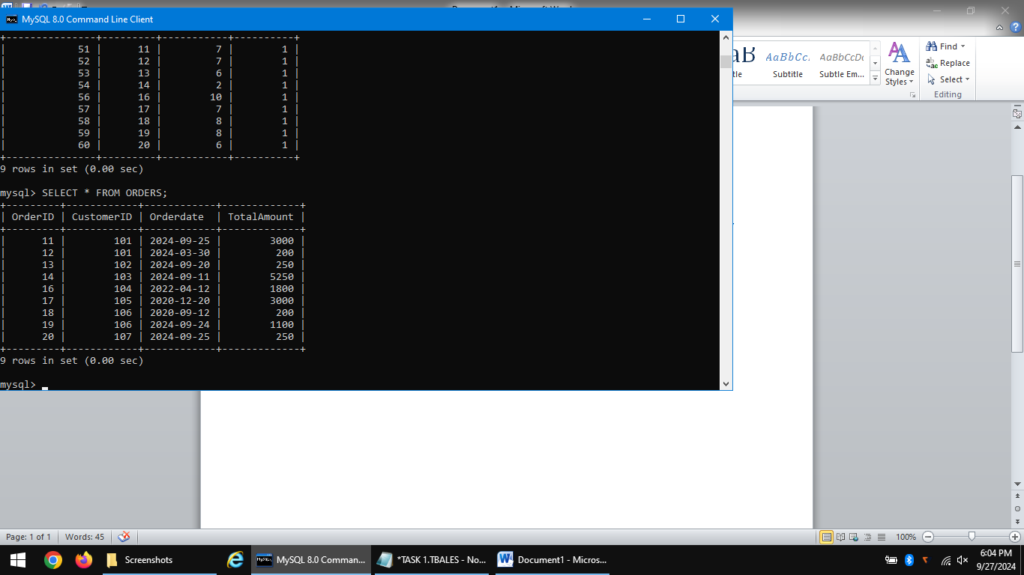

**INSERT----->ORDERDETAILS**

**INSERT INTO OrderDetails VALUES(51,11,7,1);**

**INSERT INTO OrderDetails VALUES(52,12,7,1);**

**INSERT INTO OrderDetails VALUES(53,13,6,1);**

**INSERT INTO OrderDetails VALUES(54,14,2,1);**

**INSERT INTO OrderDetails VALUES(55,15,3,1);**

**INSERT INTO OrderDetails VALUES(56,16,10,1);**

**INSERT INTO OrderDetails VALUES(57,17,7,1);**

**INSERT INTO OrderDetails VALUES(58,18,8,1);**

**INSERT INTO OrderDetails VALUES(59,19,8,1);**

**INSERT INTO OrderDetails VALUES(60,20,6,1);**

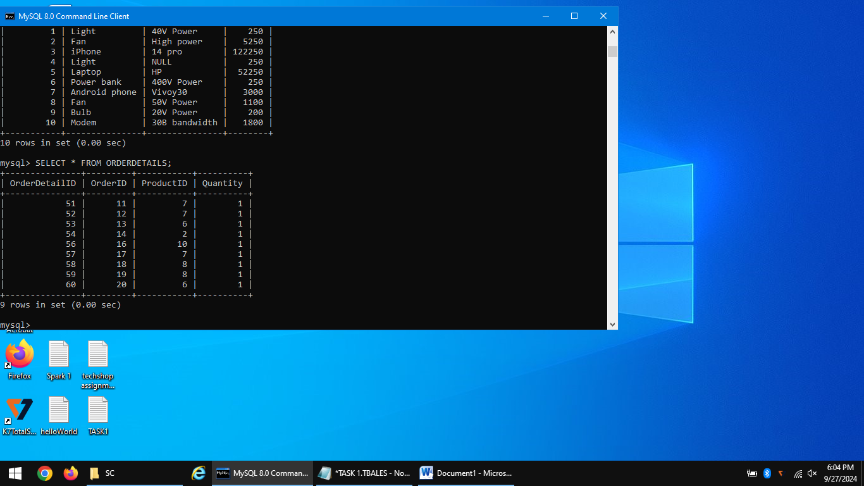

**INSERT---->INVENTORY**

**INSERT INTO Inventory VALUES(201,1,10,11);**

**INSERT INTO Inventory VALUES(202,2,100,150);**

**INSERT INTO Inventory VALUES(203,3,10,20);**

**INSERT INTO Inventory VALUES(204,4,50,67);**

**INSERT INTO Inventory VALUES(205,5,9,10);**

**INSERT INTO Inventory VALUES(206,6,10,11);**

**INSERT INTO Inventory VALUES(207,7,300,500);**

**INSERT INTO Inventory VALUES(208,8,10,18);**

**INSERT INTO Inventory VALUES(209,9,100,540);**

**INSERT INTO Inventory VALUES(210,10,100,110);**

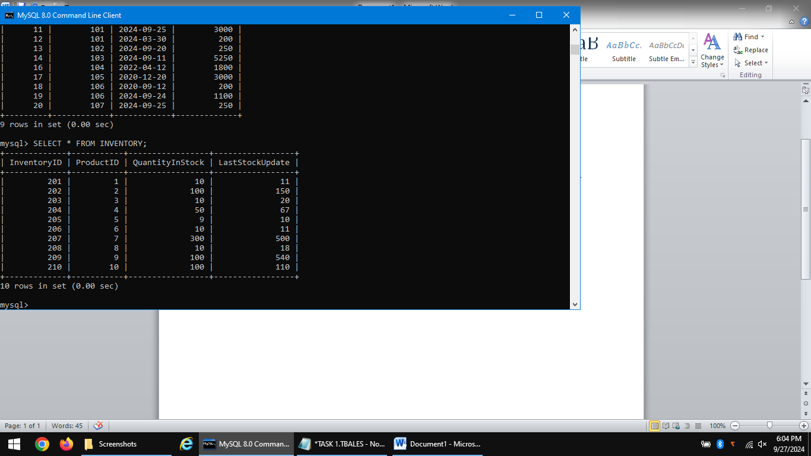

**3.ER DIAGRAM:**

